

Practices for Secure Software Report

Table of Contents
Document Revision History 3
Client 3
Instructions 3
Developer 4
1. Algorithm Cipher 4
2. Certificate Generation 4
3. Deploy Cipher 5
4. Secure Communications 5
5. Secondary Testing 6
6. Functional Testing 8
7. Summary 8
8. Industry Standard Best Practices 8

Document Revision History

Version | Date | Author | Comments
1.0 | [2/22/2026] | Nathan Perry

Client



Instructions

Submit this completed practices for secure software report. Replace the bracketed text with the relevant information. You must document your process for writing secure communications and refactoring code that complies with software security testing protocols.

- Respond to the steps outlined below and include your findings.
- Respond using your own words. You may also choose to include images or supporting materials. If you include them, make certain to insert them in all the relevant locations in the document.
- Refer to the Project Two Guidelines and Rubric for more detailed instructions about each section of the template.

Developer
Nathan Perry

Algorithm Cipher

Artemis Financial requires secure communication and file verification to protect sensitive financial data transmitted through its web application. To address these security vulnerabilities, the SHA-256 cryptographic hash algorithm was implemented for checksum verification, and TLS (Transport Layer Security) was deployed for encrypted communications over HTTPS.

SHA-256 (Secure Hash Algorithm 256-bit) is a member of the SHA-2 family developed by the National Security Agency (NSA). It is a one-way cryptographic hash function that produces a fixed 256-bit (64 hexadecimal character) output regardless of input size. Because it is computationally infeasible to reverse or generate collisions, SHA-256 is widely used in digital signatures, certificate validation, file integrity verification, and blockchain systems.

The 256-bit output provides strong collision resistance and preimage resistance. Collision resistance ensures that two different inputs cannot feasibly produce the same hash value. Preimage resistance prevents attackers from reconstructing the original input from the hash. These properties make SHA-256 appropriate for verifying file integrity in Artemis Financial’s checksum implementation.

Hash functions differ from encryption algorithms because they are one-way functions and do not use symmetric or asymmetric keys. However, in secure communication protocols such as TLS, both symmetric and asymmetric cryptography are used together. Asymmetric encryption (such as RSA) is used during the handshake process to securely exchange keys. After key exchange, symmetric encryption (such as AES-256) is used for performance and efficiency during the communication session. Secure random number generation is essential during this process to generate session keys and prevent predictability attacks.

Historically, earlier algorithms such as MD5 and SHA-1 were widely used but are now considered cryptographically broken due to collision vulnerabilities. Modern standards recommend SHA-256 or stronger (SHA-3) for hashing and AES-256 with TLS 1.2 or TLS 1.3 for encryption. By implementing SHA-256 and HTTPS with TLS, Artemis Financial’s application now aligns with current industry security standards and protects data integrity and confidentiality.

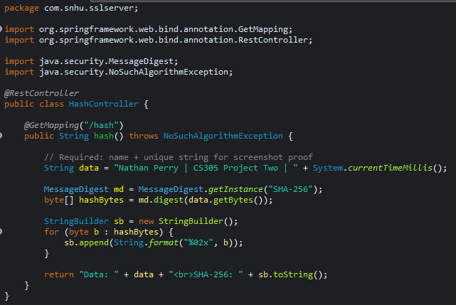

Certificate Generation

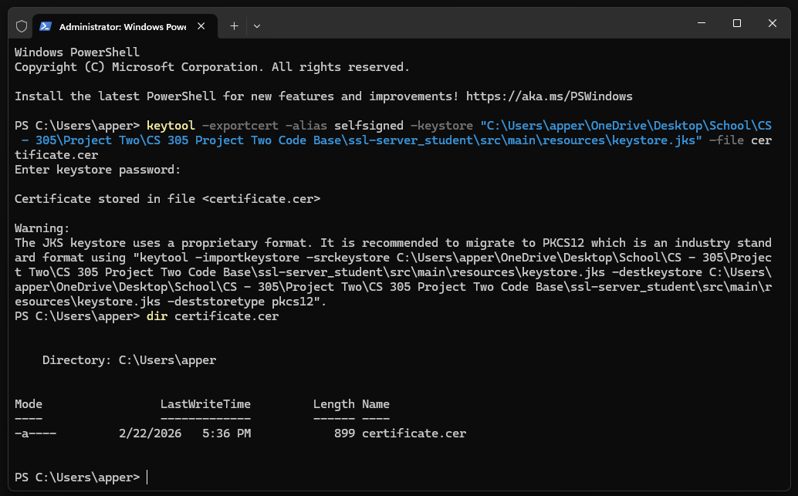

This screenshot demonstrates the successful export of the self-signed SSL certificate from the Java keystore using the keytool -exportcert command. The certificate was exported to certificate.cer, and the directory listing confirms the file was created with the expected timestamp and file size. This verifies that the application’s TLS certificate was properly generated and stored, enabling secure HTTPS communication. Exporting the certificate is an important step in validating proper certificate management and ensuring encrypted connections can be established.

Deploy Cipher

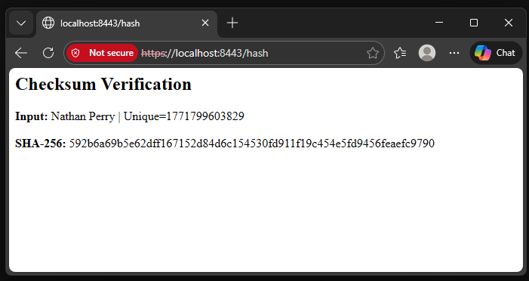

This screenshot shows the deployed checksum verification endpoint running over HTTPS at https://localhost:8443/hash. The application successfully generates a SHA-256 hash value based on the provided input string, which includes a unique timestamp to prevent replay or duplication. The 256-bit hexadecimal output confirms that the SHA-256 cryptographic algorithm is functioning correctly. This demonstrates that data integrity protection has been successfully implemented within the application.

Secure Communications

The browser address bar confirms that the application is running over HTTPS on port 8443, indicating that TLS encryption is active. Although the browser displays a warning due to the use of a self-signed certificate, the connection is encrypted and secured using TLS. This ensures confidentiality and protects transmitted data from interception or tampering. Enabling HTTPS replaces insecure HTTP communication and aligns the application with modern secure communication standards.

Secondary Testing

This screenshot displays the execution of OWASP Dependency-Check, a static analysis security tool used to identify known vulnerabilities in third-party dependencies. The scan completed successfully, and the output indicates that the application’s libraries were analyzed against the National Vulnerability Database (NVD). A detailed HTML report was generated for review. This secondary testing step strengthens application security by detecting outdated or vulnerable components that could expose the system to known exploits.
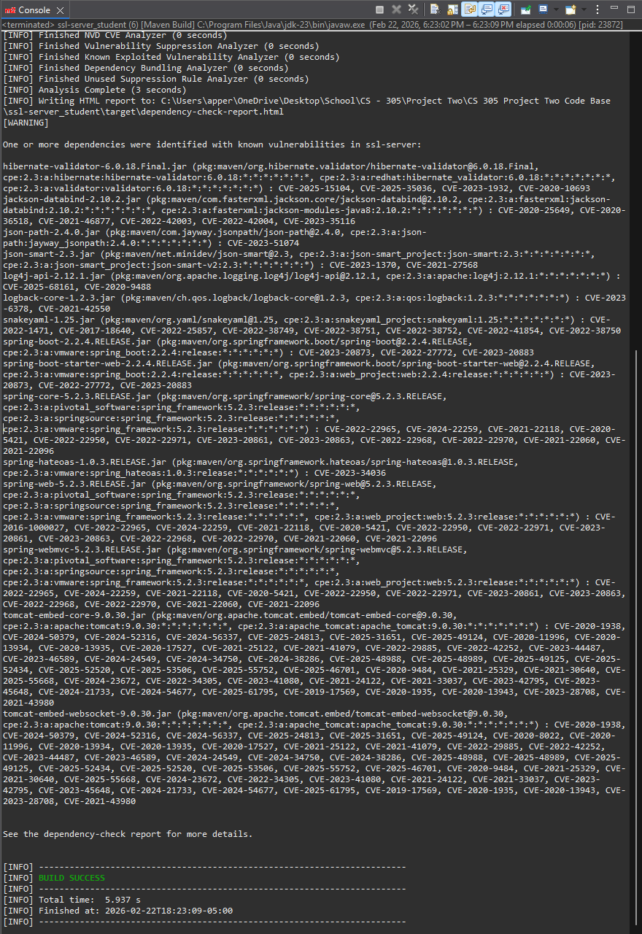

Functional Testing

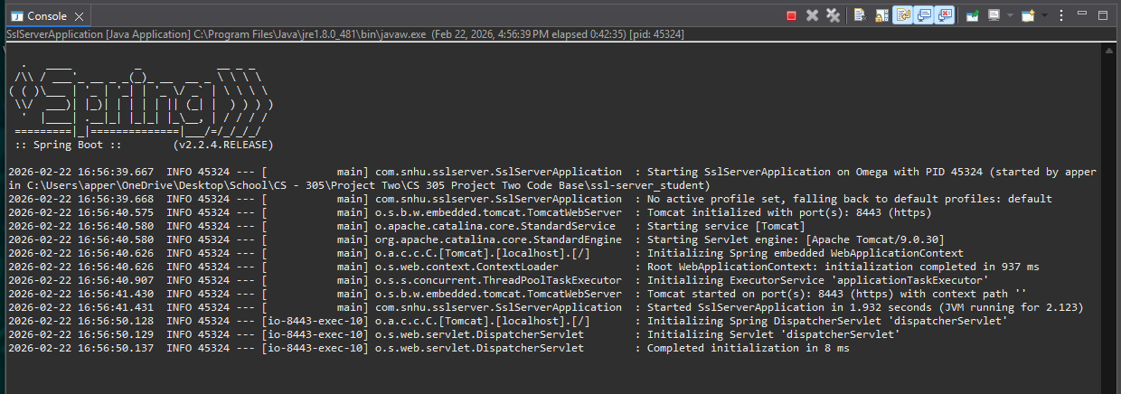

This screenshot confirms successful functional testing of the refactored application. The Spring Boot console output shows that the embedded Tomcat server started on port 8443 using HTTPS. The application initialized without errors and successfully deployed the secure /hash endpoint. This validates that the implemented security controls, including TLS encryption and SHA-256 hashing, function correctly within the running environment.

Summary

The Artemis Financial application was refactored following the vulnerability assessment process flow. The primary areas of security addressed included data integrity, secure communications, cryptographic implementation, dependency management, and secure configuration.
First, a SHA-256 checksum mechanism was implemented to ensure data integrity during transmission. This mitigates tampering and ensures file verification. Second, secure communications were enforced by enabling HTTPS with TLS encryption and configuring a self-signed certificate. This protects data confidentiality and prevents interception attacks.
Additional security layers were added through dependency analysis using OWASP Dependency-Check to identify known third-party vulnerabilities. Manual code review ensured syntactical correctness and logical integrity.
By combining cryptographic hashing, encrypted communications, certificate management, static analysis, and manual testing, multiple defensive layers were added to the application. This layered security approach follows defense-in-depth principles and reduces overall risk exposure.

Industry Standard Best Practices

Industry standard best practices were applied throughout the refactoring process to mitigate known vulnerabilities and maintain application security.
First, modern cryptographic standards were used. SHA-256 replaced weaker algorithms such as MD5 and SHA-1, which are susceptible to collision attacks. TLS was used instead of unsecured HTTP to encrypt data in transit. These decisions align with NIST recommendations and OWASP guidelines.
Second, secure configuration management was implemented by properly storing keystore credentials and enabling encrypted communication through application properties. Sensitive information was not hard-coded directly into business logic.
Third, static analysis tools (OWASP Dependency-Check) were used to validate third-party libraries against known vulnerabilities in the National Vulnerability Database. This ensures that the application does not rely on insecure or outdated dependencies.
Applying industry-standard best practices strengthens Artemis Financial’s reputation, protects customer trust, reduces legal and compliance risk, and aligns the organization with modern cybersecurity frameworks. Secure coding is not only a technical requirement but also a business necessity that protects financial data and organizational integrity.

